**User Documentation**

NEAT Lab Web Analytics Tool

By: Blen Desta, Ryan Wendling, and Zellie Macabata

**Introduction**

The NEAT Lab Web Analytics Tool was created to compliment the Android mobile application, MyQuitPal. Our team has developed more complex visualizations, apart from MyQuitPal, to show the data more effectively. The technologies that we used were GitHub, D3.js, HTML/CSS, Slack, and SQLite. The analytics tool will continue to evolve alongside MyQuitPal to help users quit smoking.

**User Guide**

The web analytics tool only works on Firefox for the moment.

How to use the NEAT Web Analytics Tool:

Side Bar:

1. Choose a participant:
   1. There is a dropdown menu that has a list of all the participants from a study that was run in Minnesota
   2. Once a participant is chosen, you can switch between the “Individual” visualizations to see that participant’s data
2. Choose a visualization:
   1. Individual
      1. If a specific participant is chosen, then you are able to see a select few of visualizations from that participant
   2. Comparison
      1. This shows every participant's’ data with the given visualizations
3. Execution:
   1. After choosing a participant or a “Comparison” visualization, click “GO” and the visualization will show up

Main Body:

1. The entire right side, or body, will show the data visualization

**Visualizations**

1. **Individual**
   * **Detailed Small Multiple:**This visualization allows users to view their stress throughout the day and compare the data between different days. Currently, we are displaying the available data from the Minnesota study for the different participants. When a participant is selected and “GO” is pressed the data will be displayed with a label indicating the day.

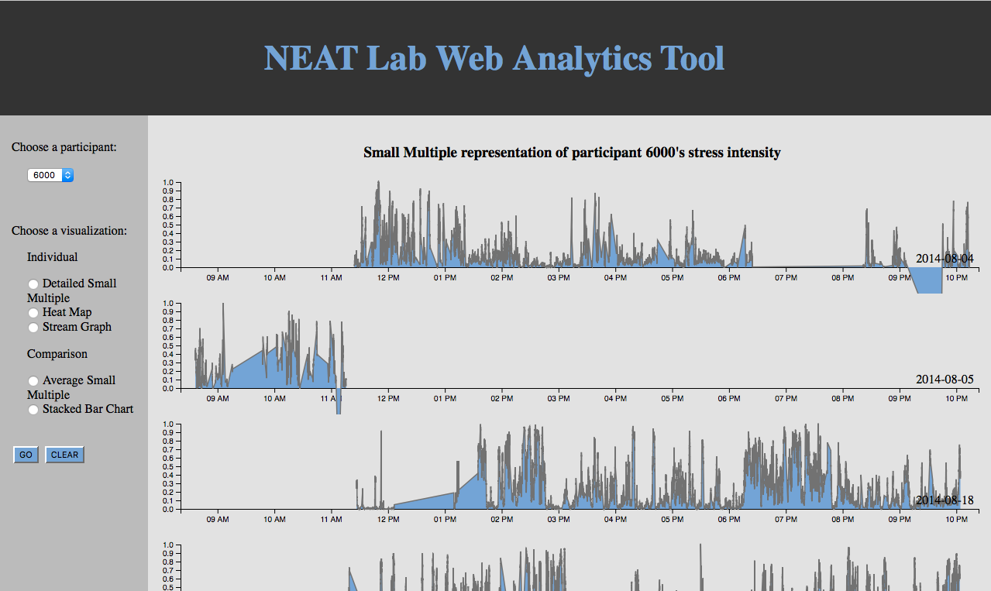

* + **Heat Map**: We chose this visualization because we wanted to distinguish a participant’s stress intensity against certain hours of a particular day. The darker the color of a cell indicates that there was higher stress for that hour of the day, and the lighter the color of a cell indicates lower stress levels. The legend proposes a 24 hour period, but the stress is measured based off when a participant wears the wearable device.

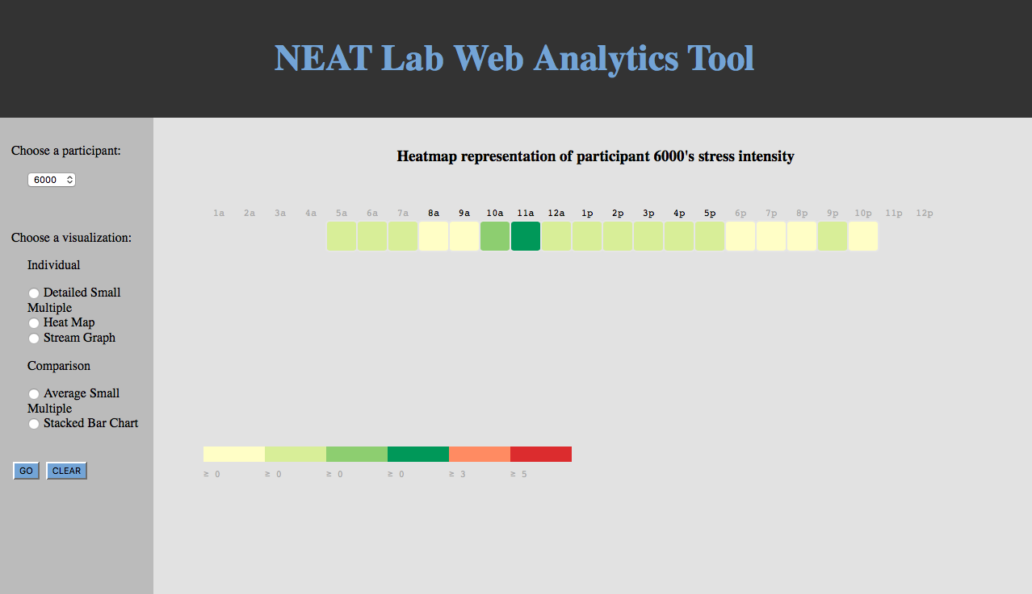

* + **Stream Graph**: Stream graph is another time series visualization that allows users to compare their stress levels between different days. The current data shown varies depending on the participant selected. The data starts at 11am until 10pm. When the mouse is hovered on a the graph, the day associated with that section will be displayed on the top left corner (see image below).

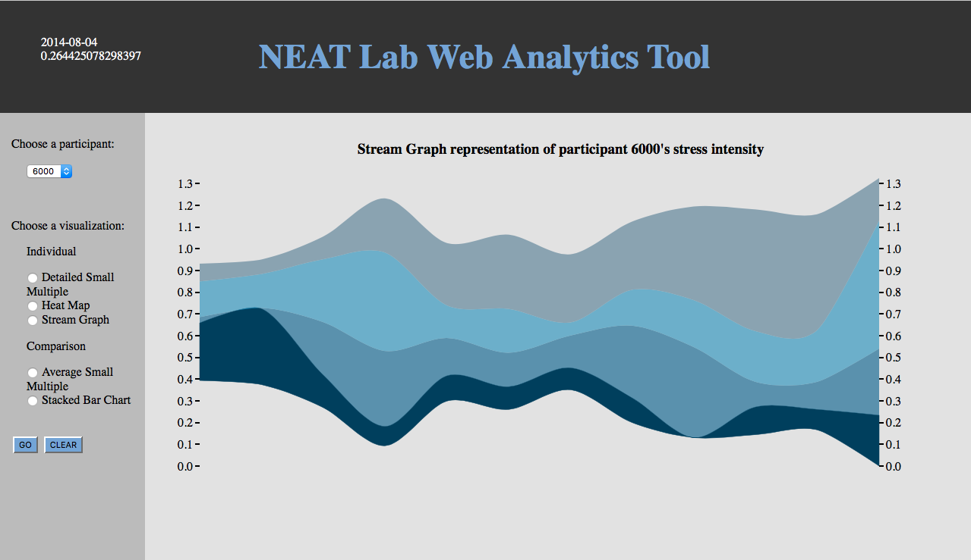

1. **Comparison**
   * **Average Small Multiple:** We have all the user’s average stress by hour per post-quit day. Basically of the four post-quit days, the graph averages each user’s stress level, by the hour. This is dependent on when the user was wearing the tracking device, so the graphs will most likely show a user’s stress with about 16 columns ranging from midnight to 8am or so.

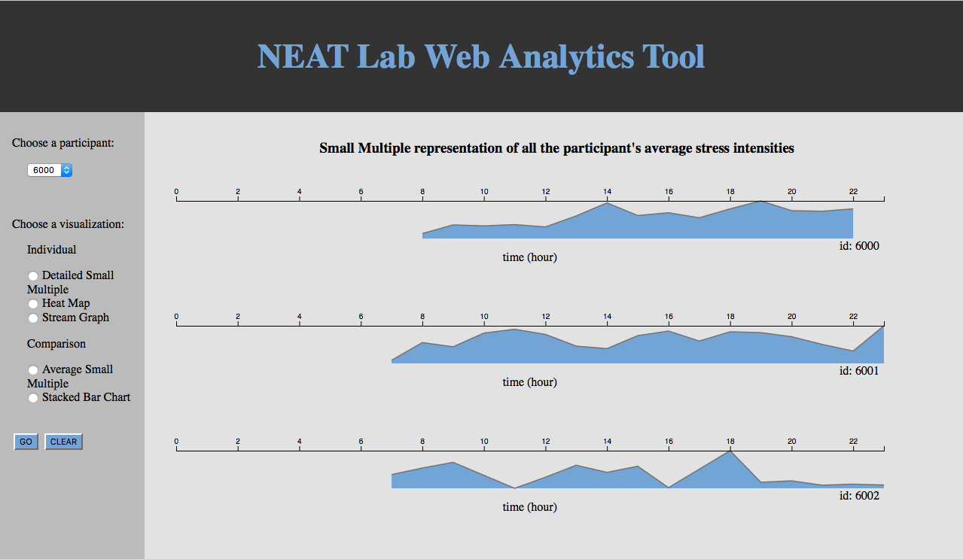

* + **Stacked Bar Chart:** This graph divides each user’s average stress by day and stacks these values to show which user might have the highest overall stress in their four day quit session. Each column represents a user which is then divided into four sections for each day’s average stress level.

